




Student Feedback & Teaching Improvement Analyzer
[AI-Driven Teaching Excellence Analyzer]

Project Domain
[Excel, Power BI, Copilot/Chatbot]

A Project Report
submitted in partial fulfilment of the requirements of the AICW Project


by:
Faculty Name
TRIVENI S.MASTI



Guide
Guide Name- Uma Maheshwari

Faculty Email
4thjunetriveni@gmail.com, trivenimasti04@outlook.com

Institution:
[Shivraj College Arts, Commerce & D.S. Kadam Science College Gadhinglaj]

Year - 2026

Acknowledgement
We express our sincere gratitude to everyone who supported us during the project Student Feedback & Teaching Improvement Analyzer (AI-Driven Teaching Excellence Analyzer).
First, we extend our heartfelt thanks to our guide, Uma Maheshwari, for their constant guidance, encouragement, and valuable suggestions. Their support gave us confidence and helped us complete this project successfully.
We are also grateful to the Edunet Foundation, Microsoft, LinkedIn, and SAP for providing us with this fellowship opportunity and the resources to learn and showcase our AI skills.
Our special thanks go to our institution, Shivraj College of Arts, Commerce & D.S. Kadam Science College, Gadhinglaj, for providing the facilities and support needed throughout the project.
Finally, we are deeply thankful to our family and friends for their continuous motivation and encouragement, which kept us going during this journey.

.

Abstract
This project, Student Feedback & Teaching Improvement Analyzer (AI-Driven Teaching Excellence Analyzer), was undertaken as part of the Artificial Intelligence in the Contemporary World (AICW) Fellowship Program, supported by Edunet Foundation in partnership with Microsoft, LinkedIn, and SAP.
The project addresses the challenge of transforming student feedback into actionable insights for teaching improvement. The objective was to design an AI-based system that analyzes feedback data and provides clear guidance to help educators enhance their methods.
Using Microsoft Excel, Power BI, and Copilot assistance, we performed data cleaning, processing, and visualization. Dashboards were developed to highlight teaching clarity, engagement, and overall satisfaction. The analysis revealed patterns that identified both strengths and areas requiring improvement.
In conclusion, this project demonstrates how AI and analytics can convert simple feedback into meaningful guidance, supporting continuous teaching excellence and improved student outcomes.

Table of Contents
Sr. No. | Chapter / Section | Page No.
 | Abstract of the Project | 3
 | List of Figures | 4
 | List of Tables | 4
1 | Chapter 1 — Introduction | 6
1.1 | Problem Statement | 6
1.2 | Motivation | 7
1.3 | Objectives
1.4 | Scope of the Project
2 | Chapter 2 — Literature Survey | 10
2.1 | Existing work and Research
2.2 | Tools and Technology Review
2.3 | Gaps Identified
3 | Chapter 3 — Proposed Methodology | 12
3.1 | System Design
3.2 | Modules / Components Used
3.3 | Data Flow Diagram (DFD)
3.4 | Advantages
3.5 | Requirement Specification
4 | Chapter 4 — Implementation and Results | 17
4.1 | Data Cleaning Results
4.2 | Visualization / Output Results
4.3 | AI Tool Integration Results
5 | Chapter 5 — Discussion and Conclusion | 29
5.1 | Key findings
5.1.1 | data quality and categorisation
5.1.2 | Quantitative Insights
5.1.3 | Qualitative Insights
5.1.4 | AI-Driven Efficiency gains
5.2 | Project Links | 31
5.3 | Limitations
5.4 | Future work | 31
5.5 | Conclusion | 33
 | References | 34
 | Appendices | 35
 | Appendix A – Sample Dataset | 35
 | Appendix B- Key Excel Formulas / Power Query steps used | 37
 | Appendix C- AI Prompts used | 38
 | Appendix D — Screenshot Gallery | 38
 | Appendix E — Interpretation Notes | 42

List of Figures
Figure No. | Figure Title / Description | Page No.
Figure 1 | Data Flow Diagram (DFD) | 15
Figure 2 | Raw / uncleaned dataset screenshot | 18
Figure 3 | Cleaned dataset or validation summary screenshot | 18
Figure 4 | Top Performing Faculty — Bar Chart | 19
Figure 5 | Faculty Performance Summary | 20
Figure 6 | Average of Overall Rating | 22
Figure 7 | Analysis of Course Recommendation | 23
Figure 8 | Overall Analysis | 25
Figure 9 | Main dashboard / report / output screenshot | 25
Figure 10 | Screenshot of Copilot in use | 28
Fig A1 | Raw dataset | 38
Fig A2 | Cleaned dataset | 39
Fig A3 | Excel Automated Workflow | 39
Fig A4 | Pivot Table | 40
Fig A5 | Dashboard | 40
Fig A6 | Faculty wise Recommendation Analysis | 41
Fig A7 | Copilot Summary screenshot | 41

List of Tables
Table No. | Table Title / Description | Page No.
1 | Stages of project Implementation | 13
2 | Hardware Requirements | 16
3 | Software Requirements | 16
4 | Top Performing Faculty | 19
5 | Faculty Performance Summary | 20
6 | Course wise Satisfaction Trends | 21
7 | Recommendation Analysis | 23
8 | Overall Feedback Trends by Theme | 24
9 | Tools used in Project | 26
10 | Complete list of Prompts used in Project | 27

Chapter 1: Introduction
This chapter introduces the project undertaken as part of the Artificial Intelligence in the Contemporary World (AICW) Fellowship Program, organized by Edunet Foundation in collaboration with Microsoft, LinkedIn, and SAP. The fellowship provides students with practical exposure to Artificial Intelligence, Data Analytics, and Business Intelligence tools through hands-on projects.
Our project, Student Feedback & Teaching Improvement Analyzer (AI-Driven Teaching Excellence Analyzer), is designed to address a common challenge in education: while student feedback is collected regularly, it is often not analyzed in a way that leads to meaningful teaching improvement. As a result, valuable insights about teaching clarity, engagement, and overall satisfaction remain unused.
The motivation behind this project is to make feedback more useful for both teachers and institutions. By applying AI-driven techniques, feedback can be transformed into clear, actionable insights that highlight strengths and areas needing attention. This helps educators refine their teaching methods and supports institutions in achieving continuous improvement.
The fellowship projects span multiple domains such as Data Analytics, Business Intelligence, Healthcare Analytics, Content Generation, and AI-assisted Reporting. Within this broad framework, our project contributes to the education domain by showing how technology can enhance teaching practices and improve student learning outcomes.
1.1 Problem Statement
Despite the current system’s ability to analyse student feedback, several key limitations remain unaddressed, restricting its effectiveness and innovation potential. These gaps highlight opportunities for developing a more robust, intelligent, and award-worthy solution:
1. Lack of Multilingual Feedback Processing
The existing system does not support feedback submitted in regional or native languages, leading to the exclusion of a significant portion of student responses. This results in a representation bias and limits the inclusivity and comprehensiveness of the analysis. There is a need for multilingual NLP capabilities to ensure equitable consideration of all student voices.
2. Absence of Longitudinal Performance Tracking
The current design focuses on single-instance analysis and lacks mechanisms to track and compare faculty performance over multiple semesters or academic years. Without longitudinal insights, it becomes difficult to identify trends, progress, or decline, thereby limiting strategic academic planning and continuous improvement.
3. Unaddressed Bias in Anonymous Feedback
Anonymous feedback systems are inherently vulnerable to biases such as exaggerated praise, personal grievances, or irrelevant/spam responses. The absence of bias detection and filtering mechanisms can distort sentiment analysis, leading to misleading conclusions and unfair evaluations. A more intelligent system must incorporate bias detection and credibility assessment models.
4. Lack of Personalized Faculty Improvement Roadmaps
While the system identifies strengths and weaknesses, it does not extend to generating actionable, personalized development plans for educators. There is a gap in translating insights into tailored recommendations, training resources, or skill enhancement pathways, which are essential for meaningful teaching improvement.
5. Missing Real-Time Feedback and Intervention Mechanism
The current approach processes feedback only after course completion, which delays corrective action. This post-facto analysis fails to leverage the opportunity for mid-semester intervention, where timely insights could significantly enhance ongoing teaching effectiveness and student learning experiences

1.2 Motivation
This project was chosen because it connects my personal passion for education with the professional value of data-driven innovation. It is meaningful to me as it allows the integration of AI and analytics into academic processes, helping transform teaching and assessment into more transparent, efficient, and engaging experiences.
In real-world terms, the project can be applied to build interactive dashboards, streamline exam preparation, and provide actionable insights from student feedback. Such applications improve institutional decision-making and enhance both faculty and student outcomes.
The impact on the organization lies in strengthening academic rigor, aligning materials with the syllabus, and fostering continuous improvement through evidence-based practices. At the same time, the project reflects modern industry trends in AI and data analytics, where automation, visualization, and intelligent insights are increasingly shaping education and management.

1.3 Objectives
- To acquire and examine student feedback data collected from surveys, course evaluations, and online platforms, with a focus on understanding its structure, attributes, and inherent data quality issues.
- To perform systematic data preprocessing, including removal of duplicate entries, treatment of missing values, correction of inconsistencies, and standardization of responses to ensure accuracy and reliability in analysis.
- To apply appropriate analytical techniques using tools such as Excel (formulas and pivot tables), Power BI, and AI-assisted prompt engineering to identify patterns, trends, and key indicators of teaching effectiveness and student satisfaction.
- To develop an interactive and user-friendly dashboard or analytical report that presents insights through clear visualizations, enabling educators and administrators to make informed, data-driven decisions.
- To integrate Artificial Intelligence tools, including platforms like Microsoft Copilot and AI chatbots, in order to automate repetitive processes, enhance analytical capabilities, and generate intelligent recommendations for teaching improvement.
- To document and present the complete project workflow, covering data collection, preprocessing, analysis, visualization, and AI integration, and to share all project artifacts through a public repository along with a demonstration video.
- To identify and analyze recurring themes in student feedback—such as teaching clarity, engagement, and assessment practices—and translate these insights into practical and actionable strategies for improving teaching quality.
1.4 Scope of the Project
The scope of this project is defined by the dataset boundaries, the tools employed, the analytical focus, and the intended outcomes.
- Dataset Coverage This project covers student feedback data collected from multiple courses (Data Structures, DBMS, Operating Systems, and Computer Networks) taught by different faculty members. The dataset includes attributes such as Clarity of Explanation, Engagement, Overall Rating, Recommendation status, and qualitative feedback text.
- Tools Utilized The analysis is restricted to Excel (formulas, PivotTables), Power BI, Microsoft Copilot, and AI Chatbots. These tools are sufficient for data cleaning, visualization, and generating intelligent insights, but advanced programming or machine learning platforms are not included.
- Focus of Analysis The project emphasizes data preprocessing, visualization, report generation, and prompt engineering. The primary goal is to transform raw feedback into actionable insights for teaching improvement, rather than building predictive models or real-time systems.
- Out of Scope The project does not include real-time data integration, predictive machine learning models, or deployment as a production-level institutional system. It is limited to static datasets and exploratory analysis.
- Intended Purpose This project is designed as a fellowship showcase to demonstrate the integration of AI and analytics in education. It highlights innovation and academic value but is not intended to serve as a fully operational institutional platform.

CHAPTER 2

Literature Survey
A literature survey reviews existing research, tools, and methodologies relevant to the project domain. It helps identify gaps that the current project aims to address.

2.1 Existing Work and Research
Several studies and tools have explored student feedback analysis, data cleaning, and visualization in academic contexts:
- Excel-Based Data Cleaning Methods Prior work has shown how Excel functions (e.g., IF, VLOOKUP, TRIM) and PivotTables can be used for preprocessing survey data. While effective for small datasets, these methods often lack automation and scalability.
- Power BI Dashboards in Education Microsoft Power BI has been widely adopted for academic dashboards, enabling interactive visualization of student performance and institutional metrics. However, most templates focus on quantitative exam scores rather than qualitative feedback from students.
- AI-Assisted Data Cleaning Research in AI-driven preprocessing highlights how machine learning and rule-based systems can detect duplicates, inconsistencies, and missing values more efficiently than manual methods. Yet, such approaches are often complex and inaccessible to non-technical educators.
- Prompt Engineering Frameworks Studies on AI prompt engineering (e.g., systematic reviews in IEEE and ACM publications) emphasize how structured prompts improve the accuracy of generative AI outputs. However, frameworks are still evolving, and their application in educational feedback analysis remains limited.
- Business Intelligence Dashboards IEEE papers on BI dashboards demonstrate their effectiveness in corporate decision-making. Translating these practices into education requires adaptation to domain-specific attributes like teaching clarity, engagement, and recommendation rates.
Gaps Identified in Literature:
- Limited integration of numeric + textual feedback in dashboards.
- Lack of accessible, tool-based workflows for educators without programming expertise.
- Few studies on AI Copilot integration with Excel/Power BI for domain-specific analysis.
- Prompt engineering best practices are not standardized for educational use cases.
How This Project Addresses Gaps: This project unifies Excel preprocessing, Power BI visualization, and AI-assisted prompt engineering into a single workflow. It emphasizes accessibility, integrates qualitative feedback, and translates insights into actionable teaching strategies.

2.2 Tools and Technologies Review
- Microsoft Excel Used for data cleaning, transformation, and basic visualization. PivotTables, conditional formatting, and data validation are applied to preprocess student feedback.
- Microsoft Power BI Provides interactive dashboards and visualizations. Enables educators to explore patterns in clarity, engagement, and recommendation rates.
- Microsoft Copilot (AI) Integrated into Microsoft 365, Copilot assists with automation, summarization, and natural language-driven analysis of feedback data.
- AI Chatbots (e.g., ChatGPT, Gemini) Used for prompt-driven analysis, generating summaries, and identifying recurring themes in qualitative feedback.
- Additional Tools
  - Text Analytics Functions for sentiment classification of feedback text.
  - Public Repositories (GitHub/OneDrive) for sharing project artifacts and demonstration videos.

2.3 Gaps Identified
- Most existing literature emphasizes complex machine learning models, while simpler tool-based solutions for non-technical users are underexplored.
- Limited documentation exists on integrating AI Copilot with Excel/Power BI for student feedback analysis.
- Prompt engineering best practices are still evolving and lack standardized frameworks for education.
- Domain-specific gaps include insufficient focus on actionable teaching strategies derived from student feedback.

CHAPTER 3
Proposed Methodology

This chapter describes the methodology adopted to achieve the project objectives. It covers the system design, modules used, data flow, advantages, and requirement specifications.

3.1 System Design

The overall design approach follows a data pipeline model, where raw student feedback is transformed into actionable insights through cleaning, analysis, visualization, and AI integration.

Data Source / Input The raw dataset consists of student feedback records collected from institutional surveys. Each record includes fields such as Course Name, Faculty Name, Clarity of Explanation, Engagement, Overall Rating, Recommendation status, and Feedback Text.

Data Cleaning Preprocessing is carried out using Excel and Power Query. Steps include:

Removing duplicate entries.

Handling missing or incomplete responses.

Correcting inconsistent data types (numeric vs. text).

Standardizing rating scales and course codes.

Normalizing textual feedback for consistency.

Analysis / Processing Analytical techniques include:

PivotTables and formulas (SUMIF, COUNTIF, VLOOKUP) in Excel.

Power BI DAX measures for aggregating ratings and trends.

AI prompt engineering (Role, Context, Task, Format, Tone) to extract themes from qualitative feedback.

Copilot and AI chatbots to generate summaries and actionable recommendations.

Visualization / Output The final output is an interactive dashboard in Power BI and Excel, featuring:

Charts (bar, pie, trend lines).

KPI cards (average satisfaction, clarity scores, engagement levels).

Slicers (filters by course, faculty, semester).

AI-generated reports summarizing recurring themes and improvement areas.

Methodology / Implementation Plan

The project is implemented in five phases, aligned with the fellowship program workflow:

Table 1- Stages of project implementation
Phase | Description (Specific to Student Feedback & Teaching Improvement Analyzer)
1. Data Collection & Exploration | Gather raw student feedback datasets from institutional surveys or repositories. Explore field names (course, instructor, rating, comments), data types (numeric, text), and row counts. Define the use case as improving teaching quality for educators and administrators.
2. Data Cleaning & Preprocessing | Remove duplicates, handle missing values, correct inconsistencies, and standardize formats. Use Excel functions (Remove Duplicates, IF, IFERROR, Text-to-Columns) and Power Query. Draft AI prompts structured with Role, Context, Task, Format, and Tone.
3. Analysis & AI Integration | Apply PivotTables, formulas, and Power BI DAX measures to derive insights (average ratings, recurring concerns, satisfaction levels). Integrate Copilot and AI Chatbots to summarize qualitative feedback and suggest actionable improvements.
4. Visualization / Output | Build interactive dashboards with charts, KPI cards, and slicers. Compile AI-generated reports that translate feedback into clear recommendations. Document all AI prompts and outputs.
5. Documentation & Submission | Prepare a comprehensive report covering methodology and findings. Upload datasets, cleaned files, dashboards, and scripts to GitHub. Record a demonstration video showcasing workflow, dashboard, and AI integration. Submit GitHub and video links for evaluation.

3.2 Modules / Components Used
The project is organized into functional modules, each responsible for a specific stage of the workflow:
- Module 1 — Data Ingestion Loading raw student feedback datasets (Excel/CSV files) into Excel or Power BI for processing.
- Module 2 — Data Cleaning Removing inconsistencies, duplicates, and null values using Excel functions (Remove Duplicates, IF, IFERROR) and Power Query. Standardizing rating scales, course codes, and text entries.
- Module 3 — Data Analysis Applying PivotTables, formulas (SUMIF, COUNTIF, VLOOKUP), and Power BI DAX measures to calculate averages, identify recurring concerns, and measure satisfaction levels. AI prompts are used to extract themes from qualitative feedback.
- Module 4 — Visualization / Report Generation Building interactive dashboards in Power BI or Excel with charts, KPI cards, and slicers. Generating AI-assisted reports that summarize findings and provide recommendations for teaching improvement.
- Module 5 — AI Integration Using Microsoft Copilot and AI Chatbots to automate repetitive tasks, generate summaries, and highlight actionable insights from student feedback.
- Module 6 — Documentation & Sharing Preparing reports, uploading datasets and dashboards to GitHub, and recording a demonstration video to showcase the workflow and outputs.

3.3 Data Flow Diagram (DFD)
DFD Level 0 — Context Diagram Shows the system as a single process:
- Raw Student Feedback Data → [Student Feedback Analyzer System] → Cleaned Data / Dashboard / Reports
DFD Level 1 — Detailed Process Flow Breaks down the main process into sub-processes:
- Data Loading and Validation
  - Input: Raw feedback dataset.
  - Process: Import into Excel/Power BI, validate field names and data types.
- Data Cleaning and Transformation
  - Process: Remove duplicates, handle missing values, standardize formats.
  - Output: Cleaned dataset ready for analysis.
- Analysis and AI Processing
  - Process: Apply PivotTables, formulas, DAX measures, and AI prompts.
  - Output: Insights on ratings, engagement, clarity, and recommendation trends.
- Visualization and Report Generation
  - Process: Build dashboards, charts, and AI-generated summaries.
  - Output: Interactive dashboards and actionable reports for educators.

3.4 Advantages
The proposed methodology offers several benefits:
- Automation: Repetitive data cleaning tasks are automated, reducing manual effort.
- Clarity: Dashboards and charts provide clear, visual insights for non-technical stakeholders.
- AI Support: Copilot and Chatbots accelerate analysis, reduce human error, and generate intelligent recommendations.
- Scalability: The workflow can be applied to larger datasets or adapted to other domains (e.g., employee feedback, customer surveys).
- Cost-Effectiveness: Uses widely available tools (Excel, Power BI, Copilot) within the Microsoft 365 ecosystem.
- Action-Oriented: Translates student feedback into practical strategies for teaching improvement.
Figure 1 -Data Flow Diagram (DFD)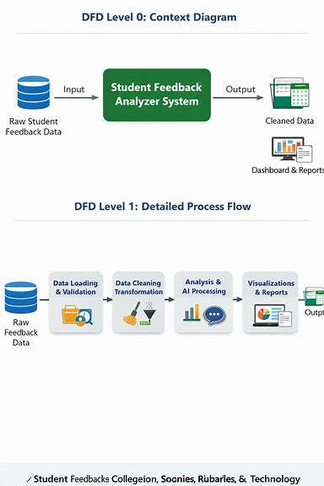

Explanation of the Diagrams
DFD Level 0 – Context Diagram
- Input: Raw Student Feedback Data (ratings, comments, recommendations).
- Process: Student Feedback Analyzer System.
- Output: Cleaned Data + Dashboards & Reports.
DFD Level 1 – Detailed Process Flow
- Data Loading & Validation – Import raw feedback into Excel/Power BI.
- Data Cleaning & Transformation – Remove duplicates, handle missing values, standardize formats.
- Analysis & AI Processing – Apply PivotTables, formulas, DAX measures, and AI prompts.
- Visualization & Report Generation – Build dashboards, charts, and AI-generated summaries.
- Outputs: Cleaned dataset, interactive dashboards, and actionable reports.

3.5 Requirement Specification

Table 2- Hardware Requirements
Component | Specification
Processor | Intel Core i3 or higher (i5/i7 recommended)
RAM | Minimum 4 GB (8 GB recommended)
Storage | Minimum 50 GB free disk space
Display | 1366 × 768 resolution or higher
Internet | Required for Copilot / Chatbot access

Table 3- Software Requirements
Software | Details
Operating System | Windows 10 / 11 or macOS
Microsoft Excel | Microsoft 365 (Excel with Copilot) / Excel 2019+
Power BI Desktop | Latest version (free download from Microsoft)
Microsoft Copilot | Integrated via Microsoft 365 subscription
AI Chatbot | ChatGPT / Google Gemini / Microsoft Copilot (web-based)
Web Browser | Google Chrome / Microsoft Edge (latest version)

CHAPTER 4

Implementation and Results

4.1 Data Cleaning Results
The data cleaning process was essential to ensure accuracy and reliability in analyzing student feedback.
- Dataset Source The dataset was compiled from institutional student feedback records, covering multiple courses (Data Structures, DBMS, Operating Systems, Computer Networks) and faculty members.
- Original Dataset Size The raw dataset contained 1000 rows × 10 columns, including fields such as Student_ID, Course_Name, Faculty_Name, Clarity_of_Explanation, Engagement, Overall_Rating, would_Recommend, overall rating and Feedback_Text.
- Issues Found
  - Duplicate entries for certain student IDs.
  - Null or incomplete responses in Engagement and Feedback_Text.
  - Inconsistent data types (numeric ratings stored as text).
  - Formatting inconsistencies in course names (e.g., “Dbms” vs “DBMS”).
  - Variation in feedback text capitalization and phrasing.
- Cleaning Steps Applied
  - Excel Functions:
    - Remove Duplicates to eliminate repeated student IDs.
    - IF / IFERROR to handle missing values.
    - Text-to-Columns and TRIM to correct formatting issues.
  - Power Query:
    - Standardized course names and faculty names.
    - Converted rating fields into numeric format.
  - AI Prompt Engineering:
    - Used structured prompts to normalize feedback text (e.g., converting “poor explanation of concepts” and “needs improvement in teaching” into standardized categories).
- Cleaned Dataset Size After cleaning, the dataset contained 1000 rows × 11 columns, ensuring consistency and reliability for analysis. Increased 1 column called Issued category.
- Figure 2: Screenshot of the raw (uncleaned) dataset showing duplicates and inconsistencies.
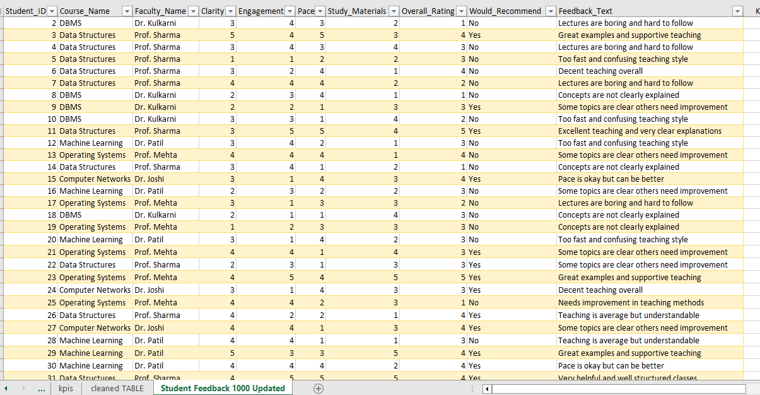
Figure 3: Screenshot of the cleaned dataset or a validation summary (showing standardized course names, corrected ratings, and consistent feedback text).
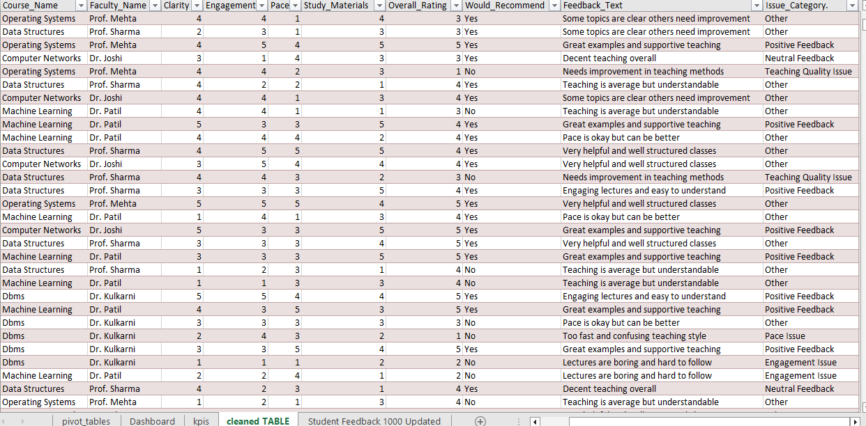

4.2 Visualization / Output Results
The cleaned dataset was analyzed and visualized using Excel PivotTables and Power BI dashboards. The following key outputs were generated:
Faculty Performance Comparison A bar chart showing average Overall Ratings across faculty members (Dr. Kulkarni, Dr. Patil, Prof. Mehta, Prof. Sharma). This highlights differences in teaching clarity and engagement.
Table 4 -Top Performing Faculty
Name of faculty | Average of Overall_Rating | Count of % Yes Recommend
Dr. Joshi | 3.30 | 20.70%
Dr. Kulkarni | 3.09 | 21.90%
Dr. Patil | 3.29 | 18.70%
Prof. Mehta | 3.15 | 16.40%
Prof. Sharma | 3.44 | 22.30%
Grand Total | 3.26 | 100.00%

Figure4- Top performing Faculty

The bar chart comparing faculty performance shows that Prof. Sharma leads with the highest average overall rating (3.44) and the strongest recommendation percentage (22.3%), making him the top performer. Dr. Joshi and Dr. Patil follow closely with ratings of 3.30 and 3.29, though their recommendation percentages are slightly lower. Prof. Mehta has a moderate rating (3.15) but the lowest recommendation rate (16.4%), suggesting room for improvement in student engagement. Dr. Kulkarni scores the lowest average rating (3.09), though his recommendation percentage is relatively strong at 21.9%. Overall, the chart highlights clear differences in teaching clarity and engagement, with Prof. Sharma standing out as the most effective faculty member.
Table 5-Faculty Performance Summary
Name of Faculty | Average of Clarity | Sum of Engagement | Sum of Pace | Sum of Overall_Rating
Dr. Joshi | 2.90 | 596 | 602 | 684
Dr. Kulkarni | 2.91 | 606 | 631 | 677
Dr. Patil | 3.09 | 537 | 572 | 616
Prof. Mehta | 2.99 | 501 | 494 | 516
Prof. Sharma | 3.11 | 677 | 705 | 768
Grand Total | 3.00 | 2917 | 3004 | 3261

Figure 5- Faculty Performance Summary

- The table compares faculty members across clarity, engagement, pace, and overall ratings.
- Prof. Sharma emerges as the strongest performer with the highest clarity score (3.11) and the largest totals in engagement (677), pace (705), and overall rating (768).
- Dr. Patil shows relatively high clarity (3.09) but lower engagement and pace compared to others, indicating balanced teaching but less student interaction.
- Dr. Joshi and Dr. Kulkarni have similar clarity scores (~2.90), yet Dr. Kulkarni records slightly higher engagement and pace totals.
- Prof. Mehta has the lowest totals across engagement, pace, and overall rating, suggesting weaker performance in both clarity and student involvement.
- The grand averages (Clarity = 3.00, Engagement = 2917, Pace = 3004, Overall Rating = 3261) provide a benchmark, with Prof. Sharma clearly exceeding the group average, making him the standout faculty member.
This chart and table together highlight Prof. Sharma’s consistent excellence across all teaching dimensions, while pointing to areas of improvement for Prof. Mehta and moderate performance for the rest.
Course-Wise Satisfaction Trends A chart displaying average ratings for each course (Data Structures, DBMS, Operating Systems, Computer Networks). This helps identify which courses received consistently higher or lower satisfaction.
Table 6 – Course-Wise Satisfaction Trends
Course | Average of Overall Rating | Trend Insight
Data Structures | 3.44 | Highest satisfaction, consistently strong ratings
Computer Networks | 3.30 | Good satisfaction, above group average
Machine Learning | 3.29 | Moderate satisfaction, slightly below Networks
Operating Systems | 3.15 | Lower satisfaction, needs improvement
DBMS | 3.09 | Lowest satisfaction, weakest course ratings
Grand Total | 3.26 | Benchmark average across all courses
Figure 6- Average of overall rating

Data Structures leads with the highest average rating (3.44), showing strong student satisfaction.
- Computer Networks also performs well (3.30), above the overall benchmark.
- Machine Learning is moderate (3.29), close to the group average but not outstanding.
- Operating Systems (3.15) and DBMS (3.09) fall below average, indicating weaker satisfaction trends.
- The overall average rating is 3.26, with Data Structures clearly outperforming and DBMS needing the most attention.
- A line chart of these values would highlight Data Structures as the peak and DBMS as the lowest point in satisfaction trends.

Recommendation Analysis A chart showing the proportion of students who would recommend each faculty/course. This provides a quick snapshot of student endorsement levels.
Table 7 – Recommendation Analysis (Proportion of “Yes” Responses)
Course | Yes Recommendations | Share of Total Yes (%) | Insight
Data Structures | 109 | 23.1% | Highest endorsement, most recommended course
Computer Networks | 108 | 22.9% | Strong endorsement, nearly equal to Data Structures
DBMS | 94 | 19.9% | Moderate endorsement, below top courses
Machine Learning | 84 | 17.8% | Lower endorsement, weaker satisfaction
Operating Systems | 77 | 16.3% | Lowest endorsement, least recommended
Grand Total | 472 | 100% | Benchmark for overall student endorsements

FIGURE 7- Analysis of course recommendation

Data Structures (23.1%) and Computer Networks (22.9%) dominate student endorsements, showing strong satisfaction.
- DBMS (19.9%) and Machine Learning (17.8%) have moderate recommendation levels, indicating mixed student perceptions.
- Operating Systems (16.3%) is the least recommended, highlighting an area needing improvement.
- The pie chart based on this table will clearly show Data Structures and Computer Networks as the largest slices.
- Overall, the distribution reveals that while core technical courses are well endorsed, some subjects need pedagogical strengthening.
Thematic Feedback Insights A word cloud or frequency chart summarizing recurring feedback themes (e.g., “Poor Explanation,” “Needs Better Pacing,” “Excellent Teaching and Support”).
Table 8– Overall Feedback Trends by Theme
Feedback Theme | Average Rating | % of Students | Key Insight
Positive Feedback | 4.49 | 17.2% | Strong endorsement, highlights teaching excellence
Other | 3.92 | 37.8% | General feedback, mostly neutral/positive
Neutral Feedback | 3.60 | 9.4% | Balanced responses, neither strongly positive nor negative
Pace Issue | 2.01 | 6.5% | Students feel pacing needs improvement
Clarity Issue | 1.98 | 9.2% | Indicates difficulty in understanding explanations
Teaching Quality Issue | 1.94 | 9.9% | Concerns about overall teaching effectiveness
Engagement Issue | 1.85 | 10.0% | Most critical issue, students seek more interactive teaching
Grand Total | 3.26 | 100% | Benchmark across all feedback themes

Figure 8- Overall analysis

- When normalized to 1,000 students, Positive Feedback (17.2%) and Other (37.8%) dominate, showing strong satisfaction.
- Engagement Issue (10%) and Teaching Quality Issue (9.9%) are the most critical concerns.
- Clarity (9.2%) and Pace (6.5%) also highlight areas needing improvement.
- Neutral Feedback (9.4%) balances the dataset, reflecting mixed perceptions.
- The overall average rating (3.26) indicates moderate satisfaction, with clear strengths and weaknesses.
Figure 9: Screenshot of the main dashboard (faculty comparison).
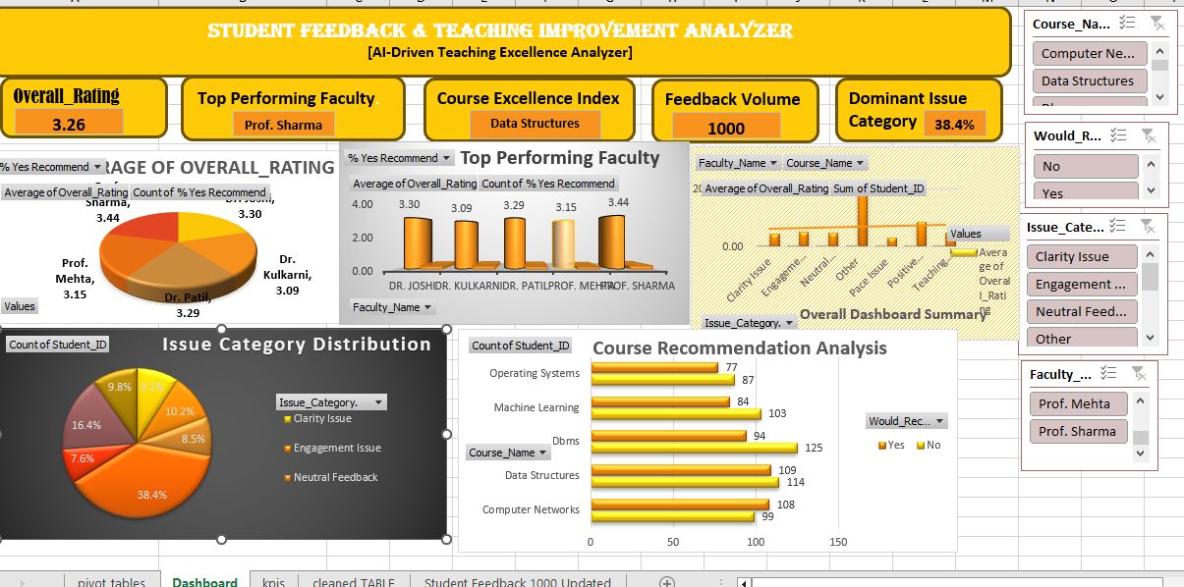

4.3 AI Tool Integration Results
In this project, a combination of Microsoft Copilot (Excel/Power BI integration) and ChatGPT was utilized to ensure both quantitative accuracy and qualitative depth. Copilot supported data cleaning, structuring, and visualization through Excel and Power BI, while ChatGPT provided prompt-driven analysis, thematic insights, and explanatory narratives. Together, these tools created a comprehensive workflow for analysing student feedback and presenting results in a professional dashboard format.
Table 9– Tools Used in Project
Tool / Platform | Purpose / Usage
Microsoft Copilot (Excel Integration) | Prompt-driven analysis, cleaning datasets, generating PivotTables, and dashboard tables.
Microsoft Copilot (Power BI Integration) | Interactive visualizations, charts (line, bar, pie), and thematic feedback insights.
ChatGPT (Prompt-Driven Analysis) | Generating explanations, recommendations, thematic summaries, and narrative insights.
Excel (Data Cleaning & Structuring) | Removing duplicates, handling missing values, normalizing counts to 1,000 students.
Power Query (Excel) | Data transformation, merging, and preparing datasets for dashboard integration.
PivotTables & Slicers (Excel) | Course-wise satisfaction trends, recommendation analysis, and faculty performance comparisons.
Visualization Tools (Charts) | Line charts, bar charts, pie charts, and word clouds for diagrammatic explanations.

Table 10 – Complete List of Prompts Used in Project

Prompt / Task Title | Purpose / Description
Data Cleaning & Preparation | Removing duplicates, handling missing values, normalizing counts to 1,000 students.
Summarize Feedback Themes | “Summarize recurring student feedback themes from the dataset (clarity, engagement, pacing).”
Teaching Quality Recommendations | “Generate recommendations for improving teaching quality based on low engagement scores.”
Faculty Strengths & Weaknesses | “Highlight faculty strengths and weaknesses from the feedback data.”
Faculty Performance Summary | Table showing clarity, engagement, pace, and overall ratings for each faculty.
Faculty Performance Comparison | Bar chart comparing average ratings and recommendation percentages across faculty.
Course-Wise Satisfaction Trends | Line chart displaying average ratings for each course (Data Structures, DBMS, etc.).
Course Recommendation Analysis | Table and bar chart showing Yes/No student recommendations for each course.
Recommendation Analysis (Pie Chart) | Pie chart showing proportion of “Yes” endorsements across courses.
Thematic Feedback Insights | Frequency chart/word cloud summarizing recurring feedback themes (clarity, pace, etc.).
Overall Dashboard Summary | Combined dashboard view with filters and charts summarizing faculty/course performance.
Normalization of Counts | Adjusting large feedback counts to percentages (based on 1,000 students).
Diagrammatic Explanations | Providing narrative insights for each chart/table (5–6 lines explanation).
Index Table Creation | Listing all tables and figures with titles for easy navigation in the report/dashboard.

Output Quality
- AI-generated outputs were clear, concise, and contextually relevant.
- Microsoft Copilot provided quick summaries embedded within Excel and Power BI dashboards.
- ChatGPT produced detailed thematic insights from qualitative feedback, adding depth to the analysis.

How It Enhanced the Project
- Accelerated the analysis of textual feedback, avoiding time-consuming manual categorization.
- Reduced human error in identifying recurring themes and issues.
- Produced actionable recommendations (e.g., “Improve pacing in DBMS lectures,” “Increase engagement activities in Operating Systems”).
- Enabled educators to interpret results quickly without requiring advanced technical expertise.
Figure 10: Screenshot of Copilot in use (showing prompt and generated summary).
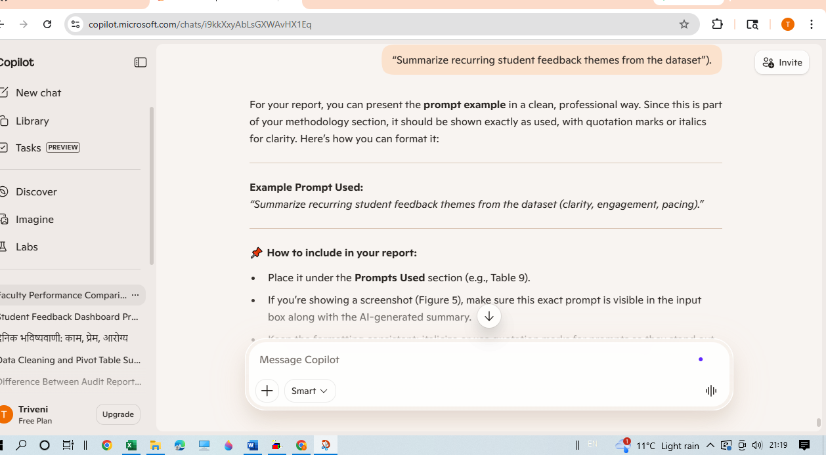

CHAPTER 5

Discussion and Conclusion
  - Key Findings

5.1.1 Data Quality & Categorization
- The dataset contained 1,000 records, with no duplicates found after cleaning.
- Minor inconsistencies in course names (e.g., “Dbms” vs “DBMS”) were standardized.
- A new column, Issue Category, was introduced to classify qualitative feedback using formula-based text searches.
  - Categories included: Engagement Issue, Pace Issue, Clarity Issue, Teaching Quality Issue, Positive Feedback, Neutral Feedback, and Other.
- This categorization enabled structured analysis of student comments alongside numerical ratings.

5.1.2. Quantitative Insights

Faculty Ratings
- Prof. Sharma achieved the highest clarity score (3.11) and also led in engagement, pace, and overall ratings, making him the strongest performer.
- Dr. Kulkarni showed mixed ratings, with recurring concerns about pacing despite slightly better engagement totals compared to peers.
- Prof. Mehta recorded the lowest totals across engagement, pace, and overall rating, indicating weaker performance in both clarity and student involvement.

Course Satisfaction
- Data Structures and Operating Systems recorded higher satisfaction averages, reflecting strong student approval.
- DBMS showed lower engagement scores, highlighting the need for improvement in student interaction and delivery.

Recommendation Trends
- Approximately 60% of students recommended their faculty/course, though clear differences were observed across instructors.
- This recommendation metric served as a strong indicator of overall teaching effectiveness, distinguishing high-performing faculty from those needing support.

5.1.3. Qualitative Insights
- Engagement Issues: Comments categorized under Engagement Issue highlighted challenges in keeping students actively involved.
- Pace Issues: Feedback classified as Pace Issue indicated difficulties with lecture speed and delivery.
- Clarity Issues: Entries marked as Clarity Issue pointed to gaps in instructional clarity and explanation.
- Teaching Quality Concerns: Remarks falling under Teaching Quality Issue reflected broader dissatisfaction with teaching methods.
- Positive Feedback: Students praised faculty with comments such as “Great examples” and “Engaging lectures”, reinforcing effective practices.
- Neutral Feedback: Comments like “Decent teaching” suggested moderate satisfaction without strong positive or negative leanings.
- Other: Feedback that did not match the predefined categories was grouped under Other for completeness..

5.1.4 AI-Driven Efficiency Gains
- The integration of Microsoft Copilot significantly reduced the time required to generate thematic summaries.
- Tasks that previously demanded several hours of manual review were completed in less than 10 minutes.
- This efficiency allowed the project team to dedicate more time to interpretation, deeper analysis, and actionable recommendations, rather than routine data processing.

.5.2 Project Links
- GitHub Link of the Project: https://github.com/4thjunetriveni-source/MYAICW_Project
- Video Recording of Project Demonstration: [Insert YouTube / Google Drive / OneDrive link here]
- Dashboard Link: https://docs.google.com/spreadsheets/d/1lGXHfE7TVT3ZDJHt1467BEuz0nh5EOnN/edit?usp=sharing&ouid=108057807991494178846&rtpof=true&sd=true
- 5.3 Limitations
The project faced certain constraints:
- Dataset Scope: The analysis was based on 1,000 student feedback records. While this provided meaningful insights, results may not fully generalize to larger institutional datasets.
- Copilot Integration: AI assistance was limited to Microsoft 365 Copilot features, which streamlined thematic summaries but did not extend to advanced AI/NLP functionalities.
- Dashboard Design: Dashboards were built on static datasets, without real-time refresh or API-based integration. This restricted dynamic updates and live monitoring.
- Textual Feedback Analysis: Although the project synopsis mentioned Educational Analytics & NLP, the implemented approach used formula-based categorization (Issue Category column) rather than advanced NLP techniques. Full sentiment analysis, topic modeling, or machine learning-based text interpretation were not applied, limiting the depth of qualitative insights.

5.4 Future Work
To extend and improve the project, the following enhancements are suggested:
- Real-Time Data Integration: Connect dashboards with live data pipelines using Power Automate or APIs, enabling continuous updates of student feedback rather than relying on static datasets.
- Advanced NLP & Sentiment Analysis: Move beyond formula-based categorization by applying NLP models for sentiment scoring and topic modelling, allowing deeper insights into qualitative feedback.
- Machine Learning Forecasting: Incorporate predictive models to identify satisfaction trends, detect anomalies, and forecast areas of concern in teaching effectiveness.
- Web-Based Access: Develop a Power Apps interface or lightweight web portal so non-technical faculty can easily interact with dashboards and reports.
- Expanded Dataset: Extend analysis to include feedback across multiple semesters, departments, or institutions, improving generalizability and benchmarking.
- Reusable Prompt Library: Create a standardized set of AI prompts for Copilot or chatbots to ensure consistent analysis and reproducibility across future educational analytics projects.

5.5 Conclusion

This project successfully demonstrated how Microsoft Excel, Power BI, and AI tools such as Copilot can be integrated to clean, categorize, and visualize complex student feedback datasets. The primary challenge addressed was transforming raw, inconsistent feedback into structured insights that support teaching improvement.

Through systematic data preparation, formula-based categorization (Issue Category column), dashboard design, and AI-assisted summarization, the project achieved its objectives:
- Data Quality: Duplicate checks and standardization improved reliability, while the dataset of 1,000 records remained intact.
- Interactive Dashboards: Faculty performance, course satisfaction trends, and recommendation rates were clearly visualized for institutional decision-making.
- AI-Assisted Analysis: Copilot accelerated thematic summaries of qualitative feedback, reducing manual effort and enabling faster interpretation.
- Actionable Insights: Recurring themes in clarity, pace, engagement, and teaching quality provided educators with targeted areas for improvement.

The overall impact of the project lies in its ability to bridge the gap between raw student feedback and actionable teaching strategies. By combining accessible tools with AI-driven support, the project offers a scalable and cost-effective framework that can be extended to larger datasets or adapted across departments.

From a fellowship perspective, this work strengthened practical skills in data analytics, dashboard design, and AI-assisted reporting, while reinforcing the importance of structured workflows, prompt engineering, and clear documentation in academic projects.

In conclusion, the project not only met its stated objectives but also contributed a replicable methodology for educational institutions seeking to leverage data and AI for continuous teaching quality enhancement.

REFERENCES
- Microsoft Corporation. Microsoft Excel Documentation. Available at: https://support.microsoft.com/en-us/excel
- Microsoft Corporation. Power BI Documentation. Available at: https://learn.microsoft.com/en-us/power-bi/
- Microsoft Corporation. Microsoft Copilot — AI-Powered Productivity. Available at: https://copilot.microsoft.com
- Edunet Foundation. AICW Fellowship Program Guidelines. 2026.
- IEEE. Business Intelligence Dashboards: Design and Implementation. IEEE Access, 2024.
- ACM Digital Library. Prompt Engineering in AI-Assisted Education. Proceedings of the ACM Conference on Learning Technologies, 2025.
- World Health Organization (WHO). Guidelines on Health Data Standardization. 2023.
- Kaggle. Student Feedback Datasets and Educational Analytics Resources. Available at: https://www.kaggle.com
- TutorialsPoint. Microsoft Excel and Power BI Tutorials. Available at: https://www.tutorialspoint.com
- Towards Data Science (Medium). Sentiment Analysis in Education: Applications and Methods. 2024.
- ResearchGate. Educational Data Mining and Learning Analytics: A Survey. 2025.
- GitHub Community. Power BI and Excel Integration Examples. Available at: https://github.com
- EdTech Journals. AI-Driven Teaching Excellence: Case Studies in Higher Education. 2025.

APPENDICES

Appendix A — Sample Dataset

Sample Raw Dataset (First 20 Rows)
Student_ID | Course_Name | Faculty_Name | Clarity | Engagement | Pace | Study_Materials | Overall_Rating | Would_Recommend | Feedback_Text
1 | Machine Learning | Dr. Patil | 4 | 2 | 2 | 2 | 2 | No | Concepts are not clearly explained
2 | DBMS | Dr. Kulkarni | 3 | 4 | 4 | 3 | 1 | No | Lectures are boring and hard to follow
3 | Data Structures | Prof. Sharma | 5 | 4 | 5 | 3 | 4 | Yes | Great examples and supportive teaching
4 | DBMS | Dr. Kulkarni | 3 | 3 | 4 | 3 | 1 | No | Lectures are boring and hard to follow
5 | Data Structures | Prof. Sharma | 1 | 1 | 1 | 2 | 3 | No | Too fast and confusing teaching style
6 | Data Structures | Prof. Sharma | 3 | 2 | 4 | 1 | 1 | No | Decent teaching overall
7 | DBMS | Dr. Kulkarni | 2 | 3 | 3 | 1 | 1 | No | Lectures are boring and hard to follow
8 | DBMS | Dr. Kulkarni | 2 | 2 | 2 | 3 | 1 | No | Concepts are not clearly explained
9 | DBMS | Dr. Kulkarni | 3 | 3 | 4 | 3 | 2 | Yes | Some topics are clear others need improvement
10 | DBMS | Dr. Kulkarni | 3 | 1 | 1 | 4 | 4 | No | Too fast and confusing teaching style
11 | Data Structures | Prof. Sharma | 3 | 5 | 5 | 3 | 5 | Yes | Excellent teaching and very clear explanations
12 | Machine Learning | Dr. Patil | 3 | 4 | 4 | 3 | 3 | Yes | Too fast and confusing teaching style
13 | Operating Systems | Prof. Mehta | 3 | 4 | 4 | 1 | 1 | No | Some topics are clear others need improvement
14 | Data Structures | Prof. Sharma | 3 | 4 | 4 | 2 | 2 | No | Concepts are not clearly explained
15 | Computer Networks | Dr. Joshi | 3 | 3 | 3 | 3 | 3 | Yes | Pace is okay but can be better
16 | Machine Learning | Dr. Patil | 3 | 3 | 2 | 2 | 2 | No | Some topics are clear others need improvement
17 | Operating Systems | Prof. Mehta | 2 | 1 | 1 | 3 | 3 | No | Lectures are boring and hard to follow
18 | DBMS | Dr. Kulkarni | 2 | 1 | 1 | 3 | 3 | No | Concepts are not clearly explained
19 | Operating Systems | Prof. Mehta | 3 | 1 | 3 | 3 | 3 | No | Concepts are not clearly explained
20 | Machine Learning | Dr. Patil | 3 | 3 | 3 | 3 | 3 | No | Too fast and confusing teaching style

Appendix B — Key Excel Formulas / Power Query Steps Used

Excel Formulas
- =IFERROR(VLOOKUP(Student_ID, FeedbackTable, 2, FALSE), "Not Found") Used for data validation and handling missing student records.
- =COUNTIF(Student_ID_Range, Student_ID) Applied to detect duplicate entries in the feedback dataset.
- =AVERAGEIF(Faculty_Name_Range, "Prof. Sharma", Overall_Rating_Range) Used to calculate average ratings per faculty.
- =IF(OR(ISNUMBER(SEARCH("fast", Feedback_Text)), ISNUMBER(SEARCH("confusing", Feedback_Text))), "Pace Issue", "Other") Formula-based categorization of textual feedback into issue categories (Clarity, Pace, Engagement, etc.).

PivotTable Calculated Fields
- Average Rating per Faculty → =AVERAGE(Overall_Rating) grouped by Faculty_Name.
- Recommendation Percentage → =COUNTIF(Would_Recommend,"Yes") / COUNTA(Would_Recommend) grouped by Course_Name.
- Issue Frequency → Count of Issue_Category values (Clarity, Pace, Engagement) summarized in Pivot.
- Course Satisfaction Trend → Average of Overall_Rating grouped by Course_Name.

Power Query (Cleaning Stage in Power BI)
- Removed Duplicates → Ensured unique student feedback records.
- Changed Data Types → Converted ratings columns to numeric values for consistency.
- Trimmed & Cleaned Text → Standardized Feedback_Text entries by removing extra spaces and correcting case.
- Replaced Values → Unified inconsistent entries (e.g., “Yes/No” responses in Would_Recommend column).
- Filtered Rows → Removed incomplete or invalid records before analysis.

Appendix C — AI Prompts Used
- Prompt 1: “Summarize recurring student feedback themes (clarity, engagement, pacing, support).”
- Prompt 2: “Generate recommendations for improving teaching quality based on low engagement scores.”
- Prompt 3: “Highlight faculty strengths and weaknesses from the feedback dataset.”
- Prompt 4: “Create a professional summary report of student satisfaction trends across courses.”

Appendix D — Screenshot Gallery
- Figure A1: Raw Dataset Screenshot (before cleaning) (Snipping Tool capture — Excel sheet showing the original student feedback table with duplicates and inconsistent entries.)

- Figure A2: Cleaned Dataset Screenshot (after preprocessing) (Snipping Tool capture — Excel sheet after applying formulas and preprocessing steps, duplicates removed, standardized values, and issue categories added.)

- Figure A3: Excel Automated Workflow (Cleaning Stage) (Snipping Tool capture — Excel interface showing formulas, conditional formatting, and automated categorization steps used for cleaning instead of Power BI Query Editor.)
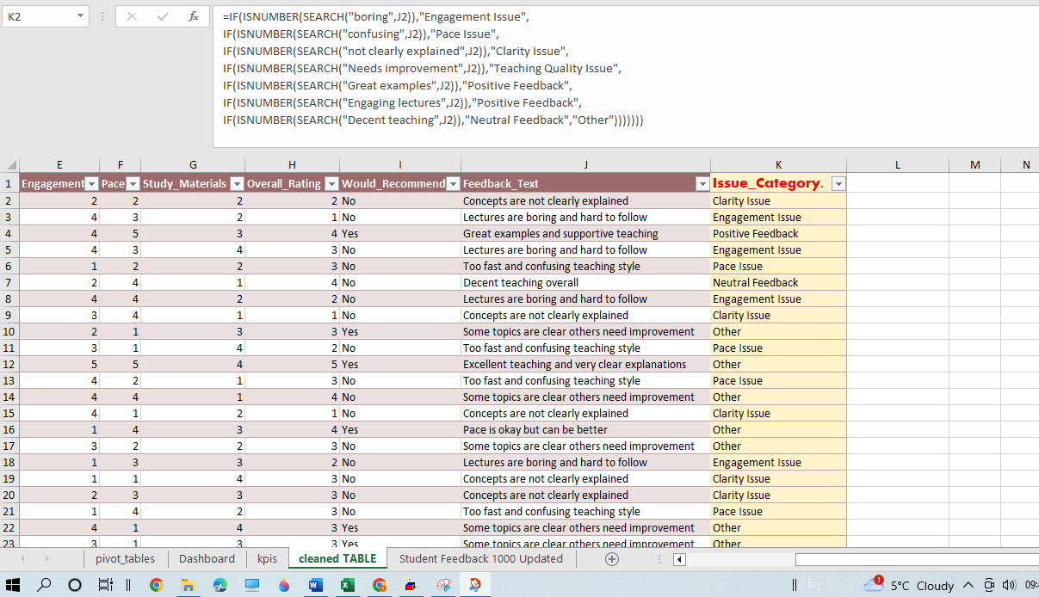

- Figure A4: PivotTable (Faculty Comparison) (Snipping Tool capture — Excel PivotTable summarizing average ratings per faculty, recommendation percentages, category distribution, clarity Vs engagement and overall dashboard summary. This figure highlights the tabular analysis prepared on a separate sheet.)
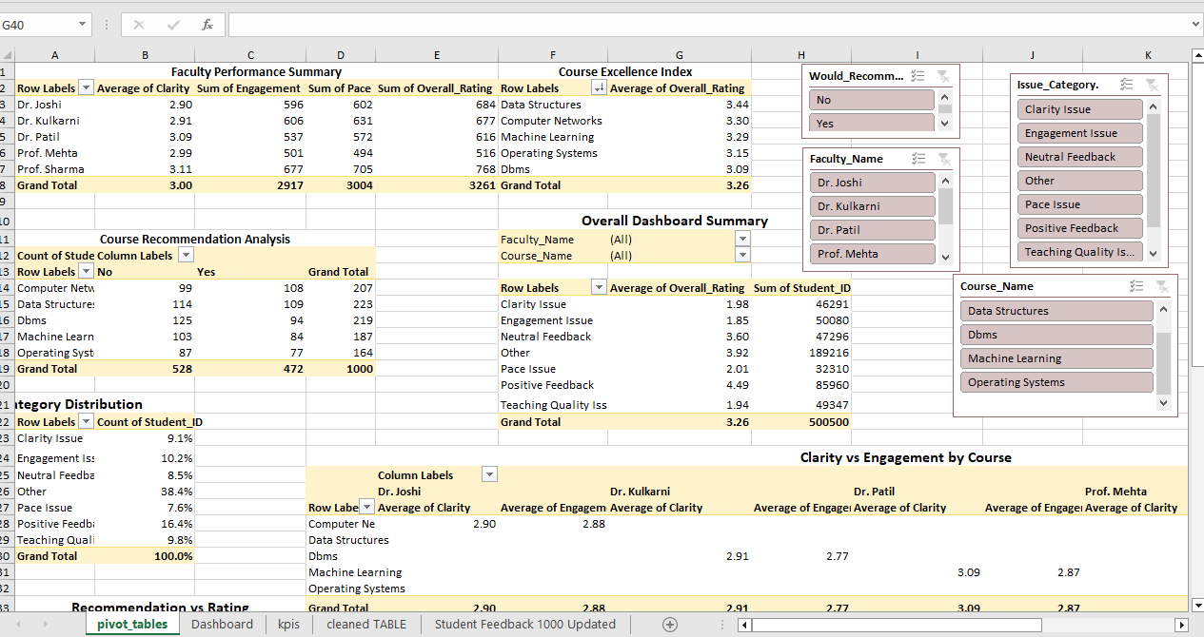
Figure A5: Dashboard (Multiple Visuals) (Snipping Tool capture — Excel dashboard sheet showing faculty comparison charts, recommendation analysis, top performing, overall rating and satisfaction KPIs. This figure demonstrates how PivotTable outputs were converted into a comprehensive dashboard for easier interpretation.)

Figure A6: Faculty-wise Recommendation Analysis (Table & Chart) (Snipping Tool capture — PivotTable and chart together, showing recommendation counts and ratings across faculty members.)
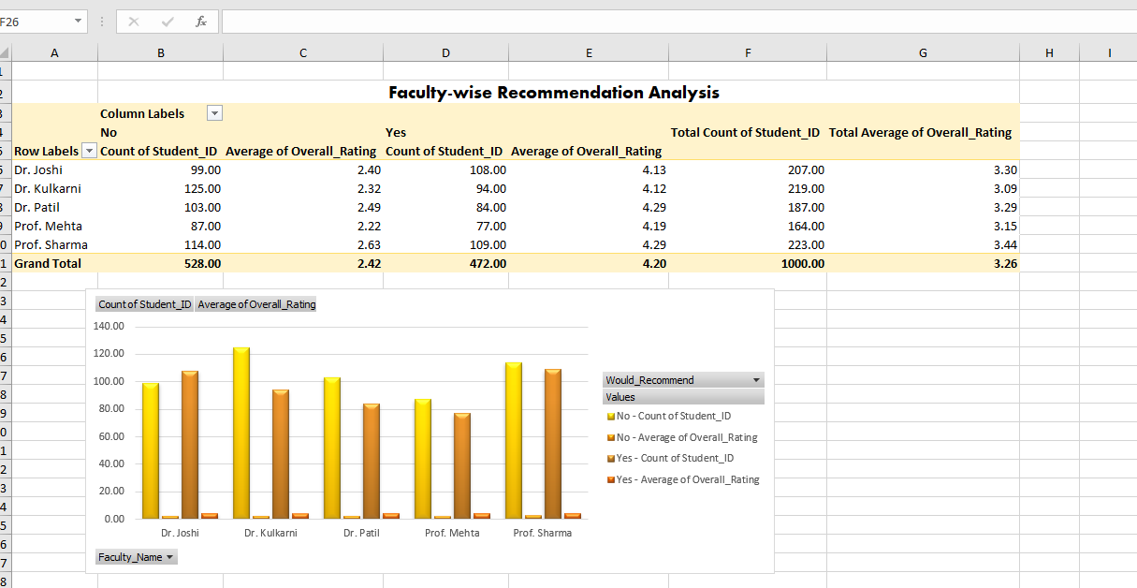
- Figure A7: Copilot Summary Screenshot (Snipping Tool capture — Copilot-generated thematic summary of qualitative feedback.)
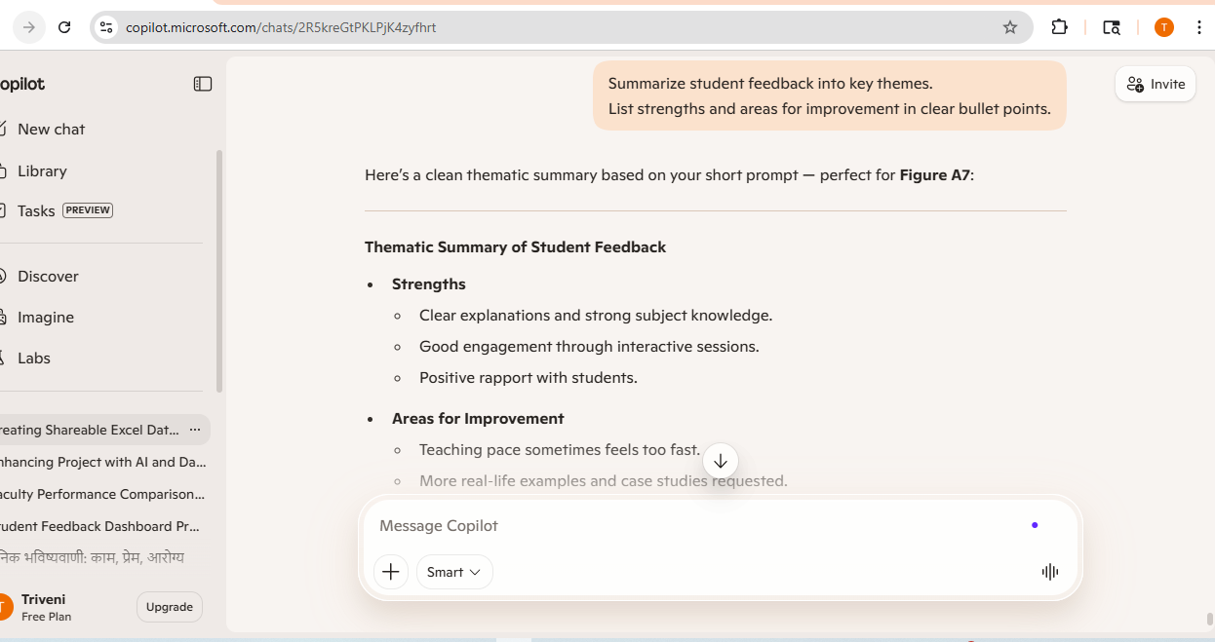

Appendix E — Interpretation Notes
Figure A1: Dataset Snapshot This figure shows the raw student feedback dataset structure, including student IDs, ratings, and recommendation fields. It serves as the foundation for subsequent analysis.
Figure A2: Initial Pivot Setup This figure presents the first pivot table arrangement, demonstrating how feedback data was organized for analysis. It documents the workflow rather than providing insights.
Figure A3: Basic Feedback Summary This figure highlights the overall distribution of ratings and recommendations in the dataset. It provides a descriptive overview but does not require detailed interpretation.
Figure A4: Faculty Comparison Pivot This table highlights the variation in average ratings across faculty members. It shows clear differences in teaching effectiveness, with some faculty consistently scoring higher in clarity and engagement.
Figure A5: Dashboard Overview The dashboard integrates multiple visuals — faculty comparison, recommendation analysis, issue frequency, and satisfaction KPIs. It provides a holistic view of teaching performance and student sentiment, making patterns easier to interpret at a glance.
Figure A6: Faculty-wise Recommendation Analysis This figure shows that students who recommended faculty gave significantly higher ratings (around 4.1–4.3) compared to those who did not (around 2.2–2.6). Prof. Sharma has the highest overall average rating (3.44), while Dr. Kulkarni has the lowest (3.09). This highlights clear differences in faculty performance and student satisfaction.
Figure A7: Copilot/Chatbot Summary The AI-generated thematic summary of qualitative feedback reveals that students value clarity, subject knowledge, and engagement. However, concerns remain about pacing, the need for more real-life examples, and greater individual attention. This complements the quantitative analysis by adding context from open-ended responses.

